elseWare

ltd.

Front2Bax



User Guide

Software version 1.0.21

Contact:
01438 222 225
07979 800 929

General 4
Action buttons 4
Entity states 4
Log in 5
The Main Screen 6
Select an Application 6
Select an Application. 6
Create New Submission 7
Select the file 7
Warnings 8
Optionally sign file 8
Add New File ( Bureaux Only ) 8
Reports 12
List reports 12
Download reports 12
View Reports 13
Report Types 13
Reports 14
Remittance advices 14
Toolbars 15
Tool tips 15
Configure Users 15
Update ISCD 15
User Guide 15
Using the f2bExplorer 16
Log in 16
Navigate 16
Program settings 17
Setting up Users 17
User name 17
Password 17
Verify Password 17
User Permissions 17
Setting up applications 18
Control Point 18
Bureaux 18
Application 20
Appendices 23
Caching Files 23
Settings 23
Usage 24
Submission Validation ONLY 27
Usage 27
Ad Hoc Payments 28
Remittance Advices 29
Introduction 29
Remittee record 29
Document format 29
Delivery 30
DD Advices 30
MultiLoad 30
Member contact numbers 32

Using the program

General

Action buttons
Blue Text An optional action
Green Text A suggested action
Red Text Close form or stop current action
Magenta text Emergency terminate of entire program

Entity states
No Status
Archived
Pending
Warning
Error
Signed
Transmitted
Confirmed
Rejected
Completed
Messages
Live
Deleted
Inactive
Resolved
Cached
Submission Validation ONLY

Log in

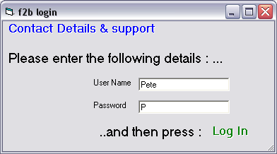

Enter you user name and password and press the green Log In button.

For details of contact numbers and how to obtain support if you have a problem, press the Contact Details & Support button at the top of the screen.

To add a new user or to edit the properties or permissions of an exiting user see Setting up Users.

The Main Screen

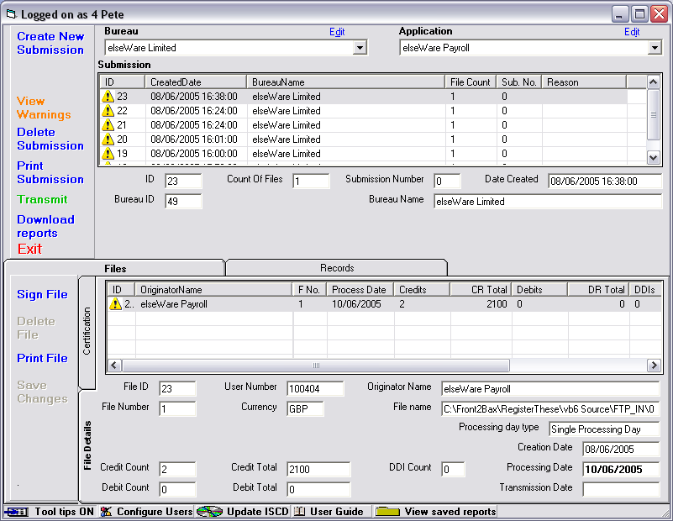

Select an Application

Select a Bureau.
Application details can be grouped under a bureau. You do not need to have a bureau number. If, for example, you wish to keep your direct debits separate from your payroll and purchase ledger payments, you could set up two bureaux ( without bureau numbers ), one to deal with payroll and purchase ledger and one to deal with direct debits. Users could be assigned rights to one and not the other.

If you do not set up more than one bureau you will not see the Bureau selection drop down.

Select an Application.
Select the application for which you wish to make a submission or for which you which to view past files and reports.
If you wish to change the details of the Application and have sufficient rights to do so, you can press the Edit button just above the Application dropdown.

Create New Submission

Select the file
Press the Create New Submission button to begin the process of transmitting a file to BACS. You will be prompted to select the file of payments, debits of DDIs that you wish to process.
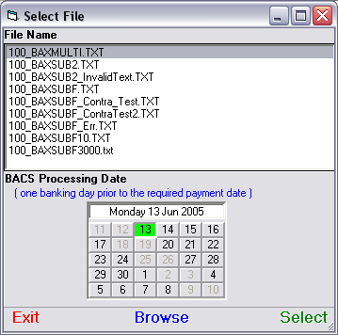

Select a file to submit to BACS. You can press the Browse button to search for other files.

To select a New Empty File or to add ad hoc payments to an existing file see Appendix A at the end of this document.

The Processing Day Calendar shows valid BACS processing days. A BACS processing day must be :

- At least one day after the transmission date. It can be forward dated by up to 30 days, so that you can submit transactions to be processed on a specific day during the following month.
- A valid banking day ( not Saturday, Sunday or a bank holiday ). The Processing Day Calendar will show these days as unavailable.
- One banking day prior to the date on which you wish the money to be transferred. Setting the processing day to a Friday will result in the money being transferred on the following Monday ( except in the cases of bank holidays, when the money will be transferred on the Tuesday ).
Press the Select button. You will be returned to the main screen where you will see the total number of records, the total amount and the processing date for the submission.

Warnings
If there are errors in the file then an additional button will appear.
View Warnings
Errors have been detected in the file. You should review the errors by pressing this button and ensure that they are acceptable before submitting the file. There may, for example, be an invalid processing date in the file or the file may contain irregular characters which have been replaced. You are strongly advised to review the errors and ensure that the automatic corrections are acceptable.
View Errors
There are significant errors in the file and it cannot be submitted. The errors must be corrected in the input file and then the file must be re-selected using the Create New Submission button.

Optionally sign file
If the totals are correct then you can optionally press the Sign File button to digitally sign the file. If you wish to change the certificate of view the raw data before signing the file you can do this by selecting the Certification tab. This is not mandatory since the submission itself is signed and access to the BACSTEL-IP site is via your digital signature. You would only really ever need to sign a file if you could not connect to BACS and you were submitting your file to a BACS bureau to send on your behalf.

Add New File ( Bureaux Only )
You will only see the Add New File button if you have a BACS bureau number.
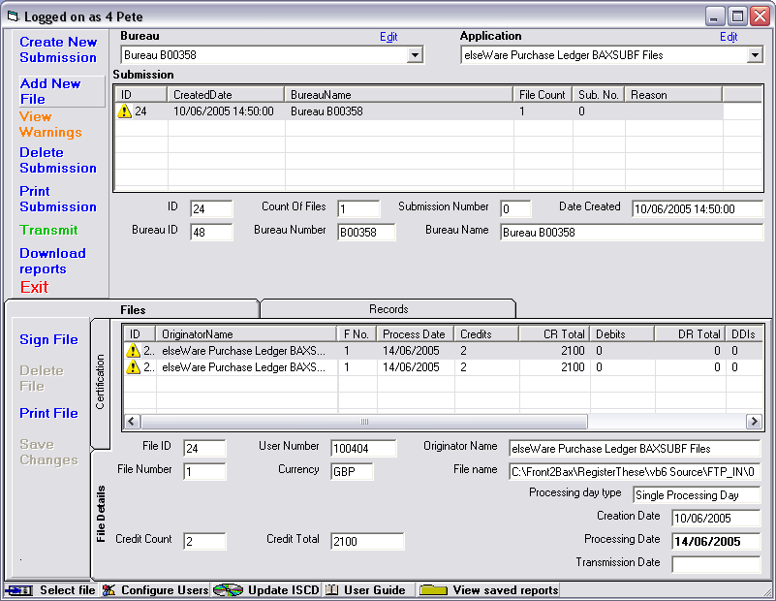
As a BACS bureau you can build multi-file submissions by adding files to the submission or by importing a multi-file submission from your account package, if it is capable of producing one. The files contained within a submission are listed in the grid on the Files tab.
Submit the file
If a card reader containing a valid card is not attached to the machine then this screen will not be available.

Having selected a submission on the Main screen, press the Transmit button. The following screen will be shown :
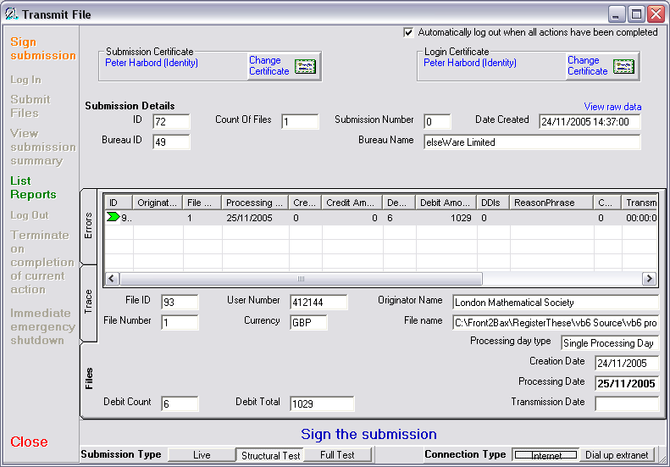

Sign Submission
Before the submission can be transmitted to BACS it must be signed. Press the Sign Submission Button and, when prompted, enter the PIN number for the card in your card reader. If you wish to change the certificate used then you should select the Certification tab and press the Change Certificate button

Log In button ( optional )
You should not need to press this button. You will be automatically logged in to BACSTEL-IP when you press the Submit Files or List Reports button. If you do press this button you will be asked to enter your PIN and then logged in to BACSTEL-IP

Submit Files button
Submit the displayed file. If you are not currently logged in then you will be asked to enter your PIN and logged into BACSTEL-IP before the file is transmitted.

Log Out button
You should not need to press this button. You will be automatically logged out when the current actions for this submission have been completed.

View Submission Summary button
When the selected file has been submitted a Submission Summary report is generated by BACS and returned to you. When this has been received the View Submission Summary button will flash. Press this button to see the detailed results of the submission and whether it has been rejected or accepted.

List Reports button
This will take you to the Report Criteria selection screen, where you can select reports to download from BACS.

Terminate on Completion of Current Action button
End the current submission as soon as possible within the confines of the current implemented transmission protocol, ensuring that the submission is terminated correctly and that the user is logged out and signed off. The transmission of the file will not be completed unless the final slice is being transmitted, and no Submission Summary will be received.

Immediate Emergency Shutdown button
Stop everything IMMEDIATELY and end the program. No more data will be sent and no reports received. The program will shut down and no error messages will be logged. For use in an emergency only.

Close button
Close the current screen..

Change Certificate
The selected certificate will be used to authenticate the login to BACSTEL-IP. To change the certificate use the Change Certificate button. The following screen will be displayed :

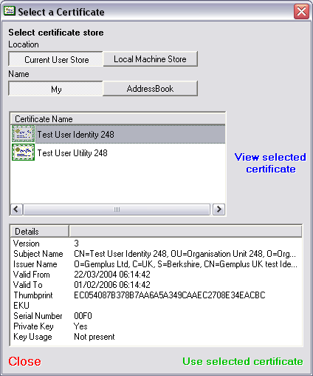

You should select the certificate that you wish to use. If the certificate that you wish to use is not displayed then it may be resident on another smart card.

Display raw data before signing
If you wish to view the raw data in the file about to be transmitted before it is signed then you should press the View Raw Data button.

Submission Type
Select the type of submission that you wish to make. If you select Structural Test then the structure of your file will be validated by BACS. If you select Full Test then the details of the file that you submit will be validated by your bank.

IF YOU DO NOT SELECT A LIVE SUBMISSION TYPE THEN YOUR FILE WILL NOT BE PROCESSED.

Connection Type
You can connect BACSTEL-IP using the internet or you can connect to the BACSTEL-IP dial up extranet. The latter will require you to have a modem and a telephone line or an ISDN adapter and an ISDN line.

This option is not functional in the current software and may be removed from future versions

Automatically download all available reports
If this box is ticked then, immediately after the Submission Summary report has been received, the software will request a download of all reports from BACSTEL-IP that have not previously been accessed. If this box is not checked then you will need to download any required reports using the List Reports button.

Automatically log out
If this box is ticked then the software will log the current user out of BACSTEL-IP after the session has ended ( i.e. all files have been submitted and all requested reports downloaded ).

If this box is not ticked then you will need to use the Log Out button to end your session with BACSTEL-IP.

Reports
Reports from BACSTEL-IP fall into a number of categories :

Submission Summary report
This report is returned is returned by BACSTEL-IP immediately after the submission has been received. It shows whether the submission has been received and passed primary validation.

Input reports
Input reports give details of files received by BACS and which have passed secondary validation.

Messages
Messaging reports give details of failed payments or debits. They may arrive several days after the file has been submitted.

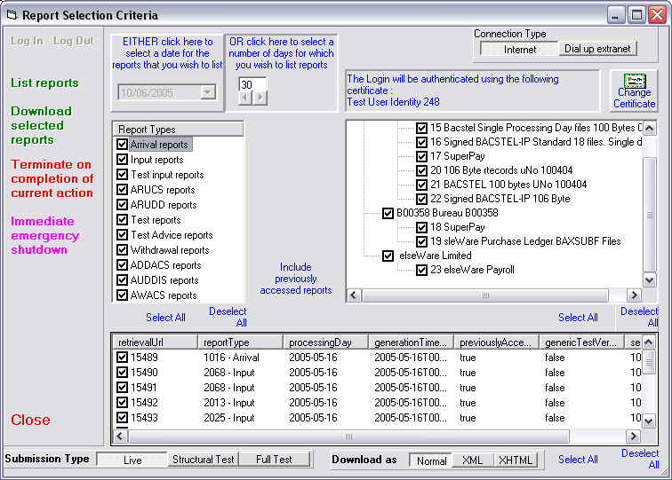

Using the Report Selection Criteria screen you can select which reports you wish to download. The Report Types list lists all the types of reports. Tick the types that you want to search for. The Tree view on the right hand side of the screen lists all the applications for which you can download reports. Tick the Applications for which you wish to search for reports. Note that the Include previously accessed reports button will show all available reports and that pressing it will toggle it to Exclude previously accessed reports.

List reports
Press this button to list all available reports for the selected criteria. When the list is displayed you should select the reports that you wish to download before pressing this button.

Download reports
Press this button to download reports.
Normal / XML / XHTML
You should select Normal. Selecting XML or XHTML will affect the operation of the system.
XML files cannot be displayed. XHTML files cannot be used to update the status of files on the system.

View Reports
On the main screen press the View Saved Reports button. The following screen will be presented, enabling you to double click on the report that you wish to view or print :
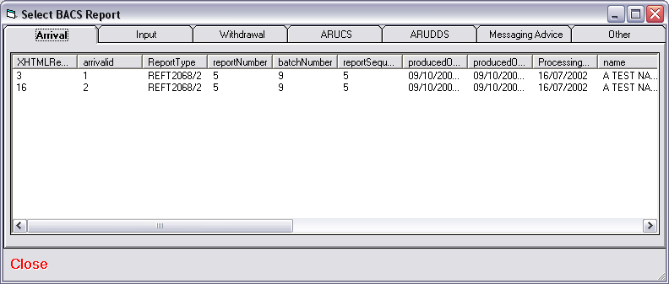

Report Types

Arrival
The arrival report indicates the arrival of a BACS file.

Input
The input report indicates that a BACS report has been processed by the banks.

Withdrawal
The withdrawal report gives details of BACS submissions that have been cancelled by the submitter

ARUCS
The ARUCS ( Automated Return of Unapplied Credits Service ) report gives details of any payments that failed for a given submission

ARUDD
The ARUDD (Automated Return of Unpaid Direct Debits )

Messaging Advice
Including AUDDIS ( Automated Direct Debit Instruction Service ), AWACS ( Advice of Wrong Account for Automated Credits Service ) reports.

Other

All other reports

Emails
In future versions of the system a variety of notifications will be sent to consumers. This option is not available in the current version.

Reports
A variety of reports are available within the system.

Remittance advices
In future versions of the software remittance advices will be available.

Toolbars

Tool tips
Tools tips can be switched on or off.

Configure Users
Press this button to add, edit or delete users. You can also use this button to grant or deny privileges or applications to selected users.

Update ISCD
Update the ISCD.

User Guide
Run this User Guide

Using the f2bExplorer
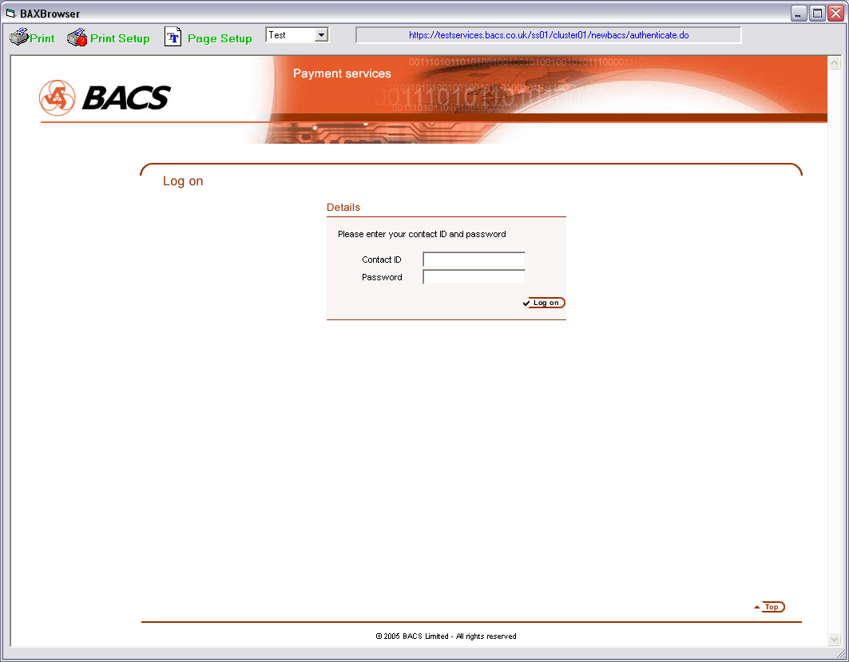

Log in
If you have a smart card attached to yuor PC you will be asked to enter your PIN, or you can log in to the web site using you contacted and PIN.

Navigate
Use the buttons and links displayed within the web pages to navigate around the BACS web site.

Program settings

Setting up Users
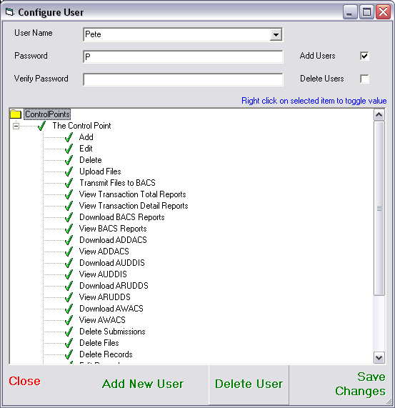

User name
The name of the user

Password
The user’s password

Verify Password
Re-type the user’s password

User Permissions
Select permissions for the user

Setting up applications

Control Point

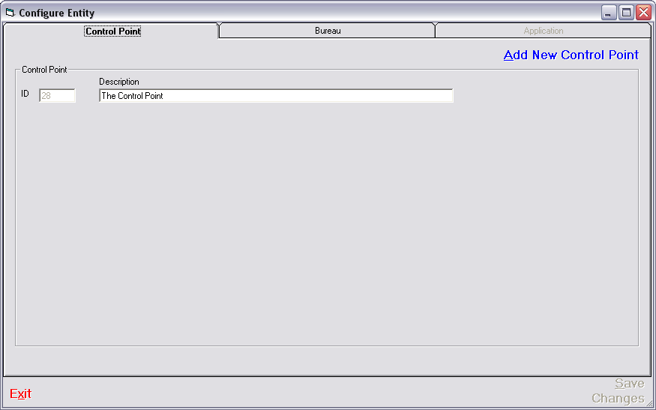
The Control Point is used for grouping Bureaux and Applications.
If you change the text you should press Save Changes and then Exit.
Description
Enter a description for the Control Point, e.g. your company name

Bureaux

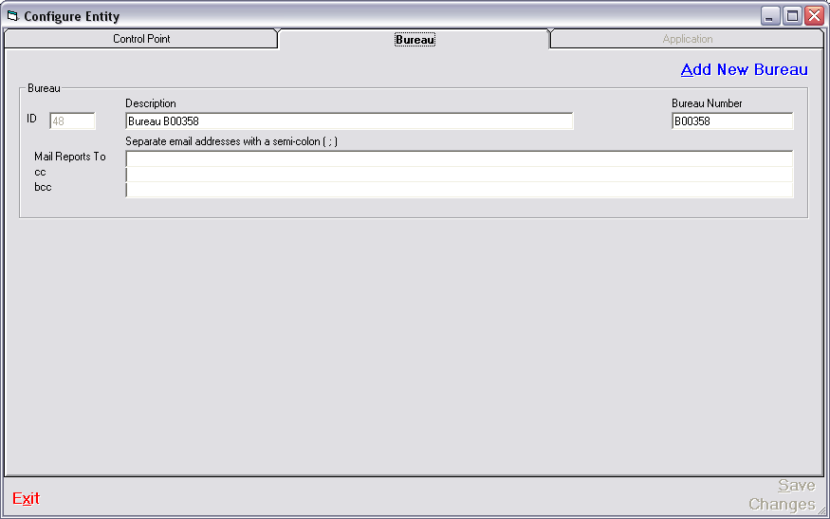

If you are not operating as a BACS bureau you should not enter a bureau number. The bureau entry can be used to group Applications into logical groupings.

If you are operating as a BACS Bureau you should group your clients under one or more Bureau entries. Bureau entries can have the same BACS bureau number or different bureau numbers.

If you change the text you should press Save Changes and then Exit.

Description
Enter the name of the bureau, e.g. your company name. If you will be entering more than on bureau then the names should be different.

Bureau Number
If you are operating as a BACS bureau you should enter your bureau number. If you are not a BACS bureau then you should leave this field blank.

Mail Reports To
Copies of reports and notifications of significant events for all applications grouped under this bureau number will be sent to the people or mail groups specified in this list.

CC
Copies of reports and notifications of significant events for all applications grouped under this bureau number will be sent to the people or mail groups specified in this list as entries on the cc line

BCC
Copies of reports and notifications of significant events for all applications grouped under this bureau number will be sent to the people or mail groups specified in this list as entries on the bcc line ( no other recipients in the list will see that these users or groups have been sent a copy ).

Application
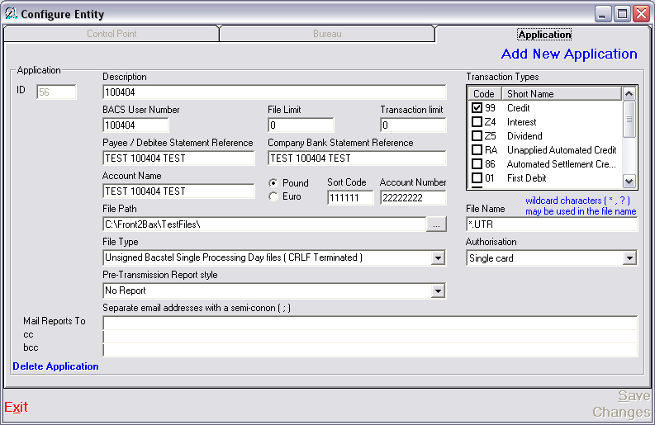

An application is a set of details that are merged with a set of credits or debits to make a BACS submission. They identify the bank account from which the credits will be taken or into which the debits will be paid.

If you change any of the text you should press Save Changes and then Exit.

Description
The description of the Application ( e.g. Company A Payroll, Company B Pension Contributions, Company C VAT, etc.. ). This description is displayed in the program to enable the user to select the correct set of details. Any combination of text and numbers can be entered.

Transaction Types
The type of transactions to be used with this BACS User Number. Most BACS User numbers are automatically set up to make payments. If you wish to collect Direct Debits you should contact your sponsoring bank.

If you are making payments you should tick 99 - Credit.
If you are collecting Direct debits you should tick : 01 - First Debit, 17 - Debit, 18 – Represented Debit and 19 – Last Debit.
If you will be issuing Direct Debit Instructions you should tick : 0N – New DDI, 0C – Cancel DDI and 0S – Set up DDI.

BACS User Number
The BACS User Number for this application. If you are operating as a BACS Bureau you should enter the BACS User Number of your client.

File Limit
The maximum amount of money allowed to be credited to or debited from this account in one file ( set of transactions ). A warning will be given if this amount is exceeded.

Transaction Limit
The maximum amount of money allowed to be credited to or debited from this account in a single transaction within a file ( set of transactions ). A warning will be given if this amount is exceeded.

User Statement Reference
The text to be printed on the bank statement of the account associated with this user number. If you are operating as a BACS Bureau his text will appear on your client’s bank statement.

Bank Statement Reference
The text to be printed on the bank statement of the person being paid or debited as a result of transactions created using this application.

Account Name
The name of the bank account from which credits are to be made or into which debits are to be received.

Currency ( Pound / Euro )
The currency in which the transactions are to be made. Transactions in Euros are not currently possible ( June 2005 ) but will be implemented shortly. Until such time any sets of transactions that specify Euros as a currency will be processed as pounds with no rate conversion in operation.

Sort Code
The sort code of the bank account to be associated with this BACS User Number. Several bank accounts can be associated with a single BACS User Number.

Account Number
The account number of the bank account to be associated with this BACS User Number. Several bank accounts can be associated with a single BACS User Number.

File Path (& browse button )
The path along which the files of payments or debits can be found. If your file is situated on a shared drive the path might be : ‘F:\Shared\Payroll\’. You can use the browse button ( with the three small dots on it ) to select a path.

File Name
The name of the file or type of file to be presented for submission to BACS. Wild cards can be used. Your file name might be : ‘Payroll Week 10.txt’ or ‘Pay*.txt’ or ‘Payroll Week ??.txt’

File Type
The type of file that contains your set of credits or debits. If the type of file that you will be using does not appear in the drop down list, or you are unsure of the type of your file you should contact your software supplier.

Authorisation
Four options are available :
Single Card
One person can sign a submission and log on to BACS using a single security card.
Two cards required to submit
One card is required to sign the submission and a different card must be inserted in order to log on to BACS.
File signing mandatory
Files must be signed before they can be transmitted, but a single card can be user for all signing.
File signing and two cards
Files must be signed before they can be transmitted and different cards must be used to sign the submission and to log on to BACS.

Pre-Transmission Report Style
Select the style of the pre-transmission report that you require. You can print at submission or file level and include records and errors if required.

Mail Reports To
Copies of reports and notifications of significant events for the application will be sent to the people or mail groups specified in this list.

CC
Copies of reports and notifications of significant events for the application will be sent to the people or mail groups specified in this list as entries on the cc line

BCC
Copies of reports and notifications of significant events for the application will be sent to the people or mail groups specified in this list as entries on the bcc line ( no other recipients in the list will see that these users or groups have been sent a copy ).

Appendices

Caching Files

Settings
The user must have the appropriate permissions in order to use File Caching.

- Cache Files
The user will be able to assign a file to the cache.
- View Cached Files
The user will be able to view files assigned to the cache for the current application.
- Add Cached File to Submission
The user will be able to assign files from the cache to a submission.
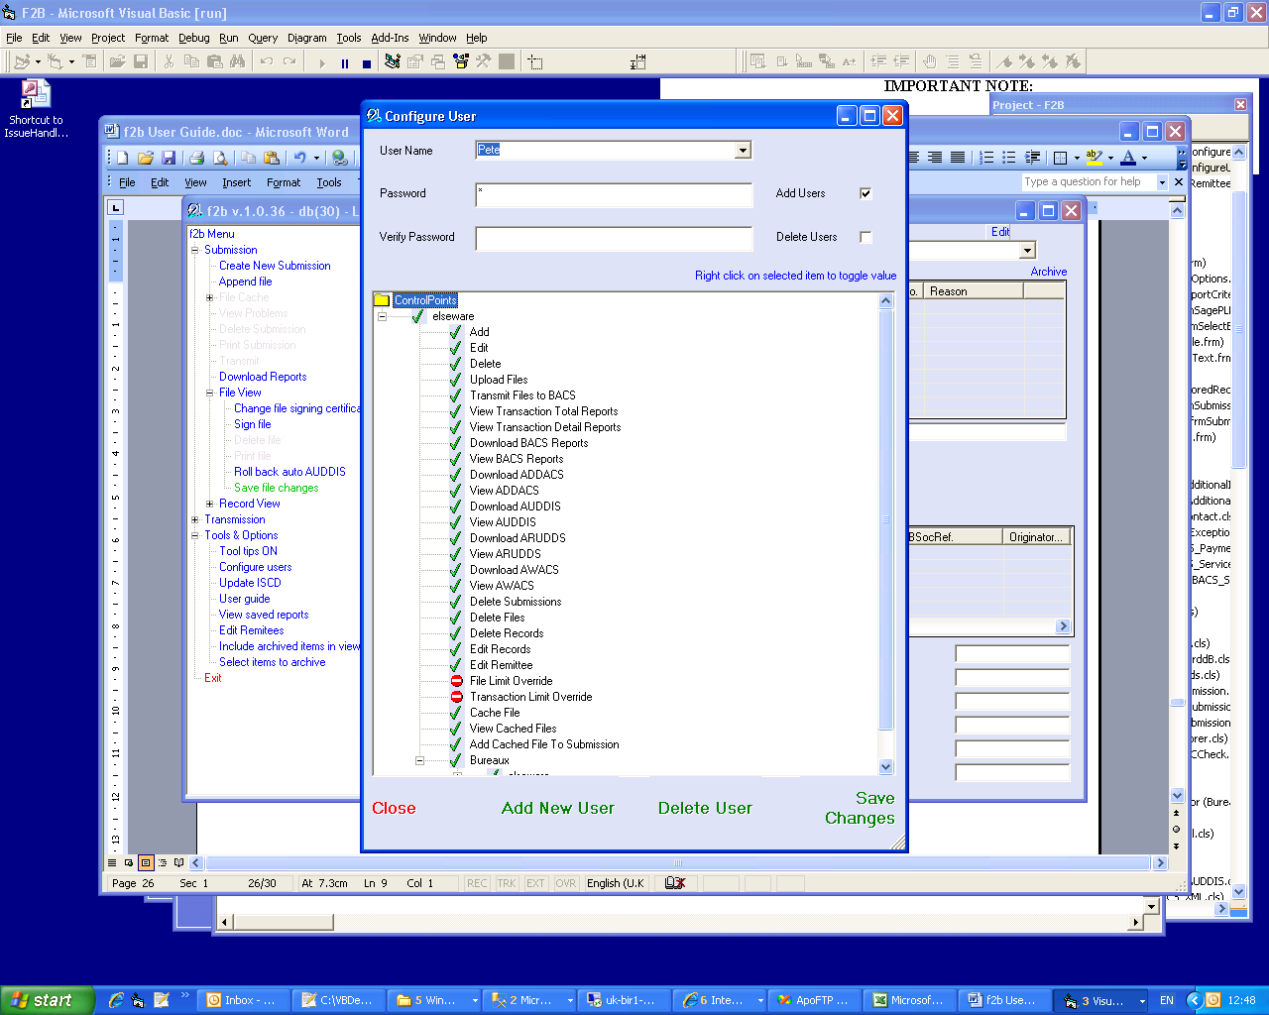

The configurations settings file f2b.INI MUST contain the following setting in the [Settings] section:
TV=TV
Usage

Select the submission that contains the file that you wish to cache. Submissions that contain more than one file cannot be cached.

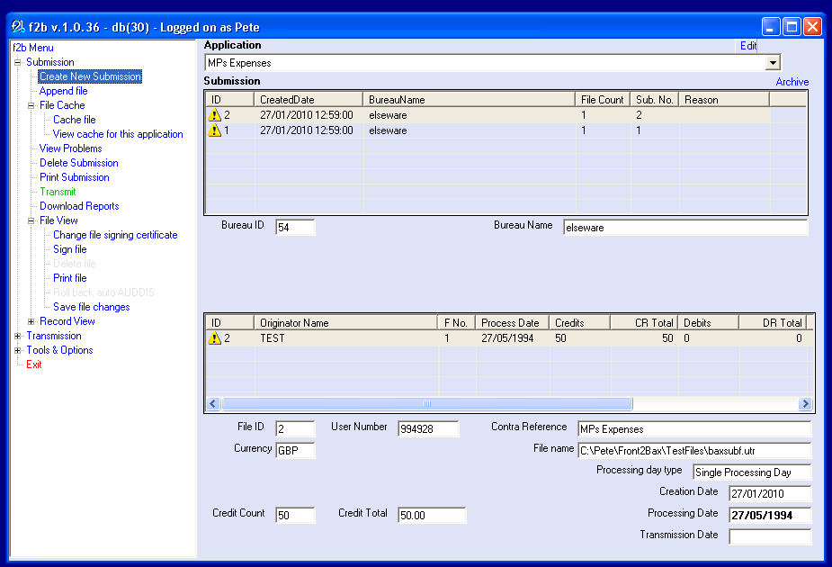

Click Cache File in the menu on the left. The submission will disappear from the list of submissions.

Cached submissions for the selected application can be viewed by clicking on View cache for this application from the menu.
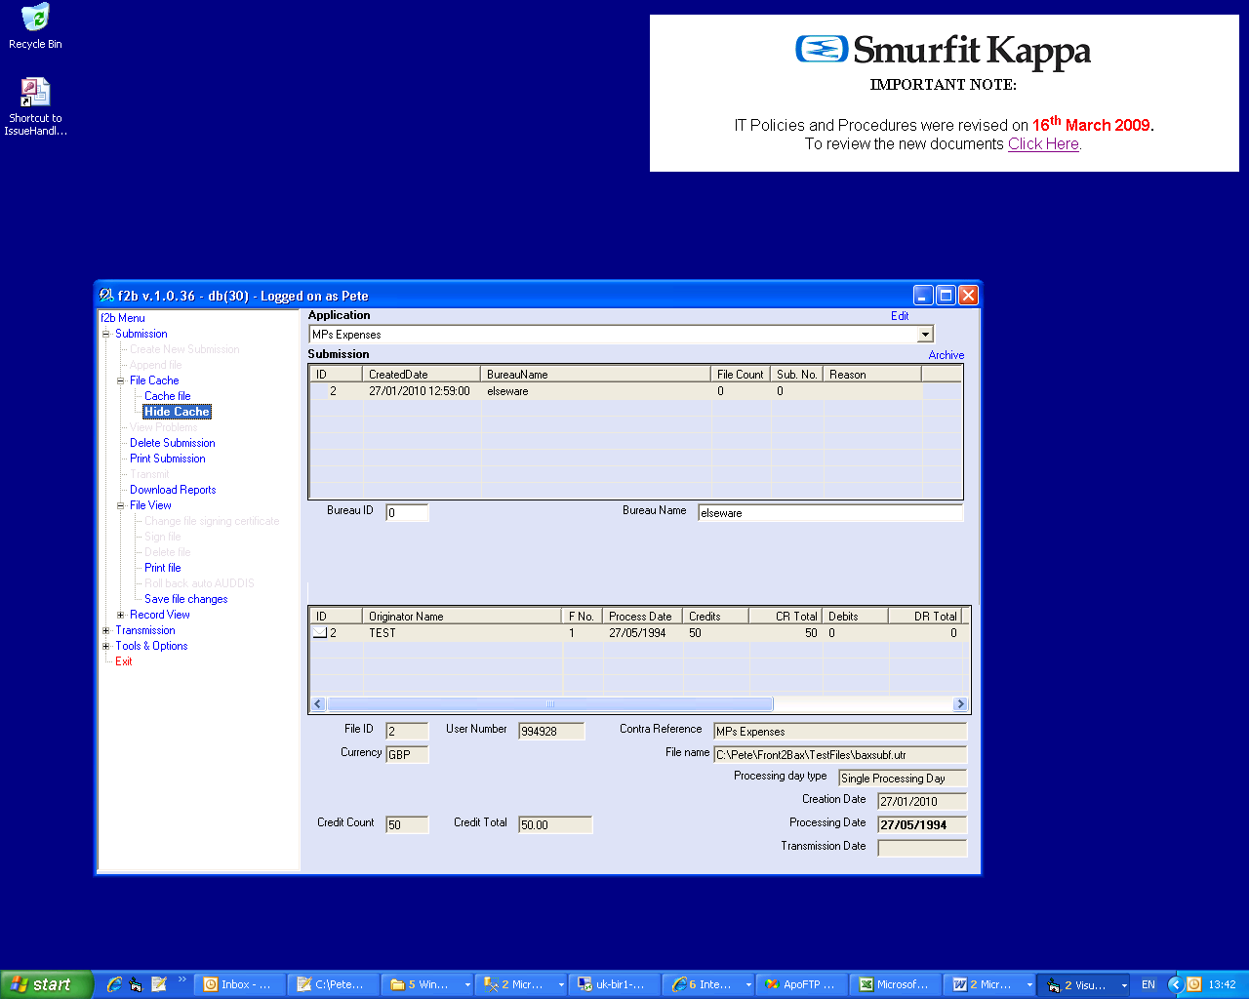

Cached submission can not be transmitted, they must be used to create a new submission or added to an existing submission. To do this ensure that the cache is hidden by pressing Hide Cache on the menu and then create a new submission as normal.

The File Selection screen contains a list of cached files for the selected application. Select a file OR a cached file, select the processing date and press Select.

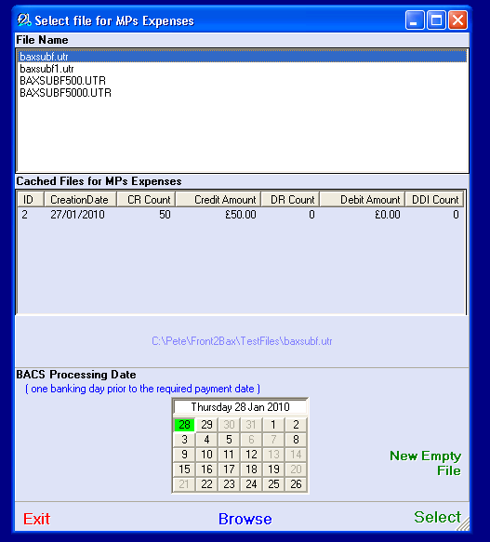

The cached file will be added to your new submission.

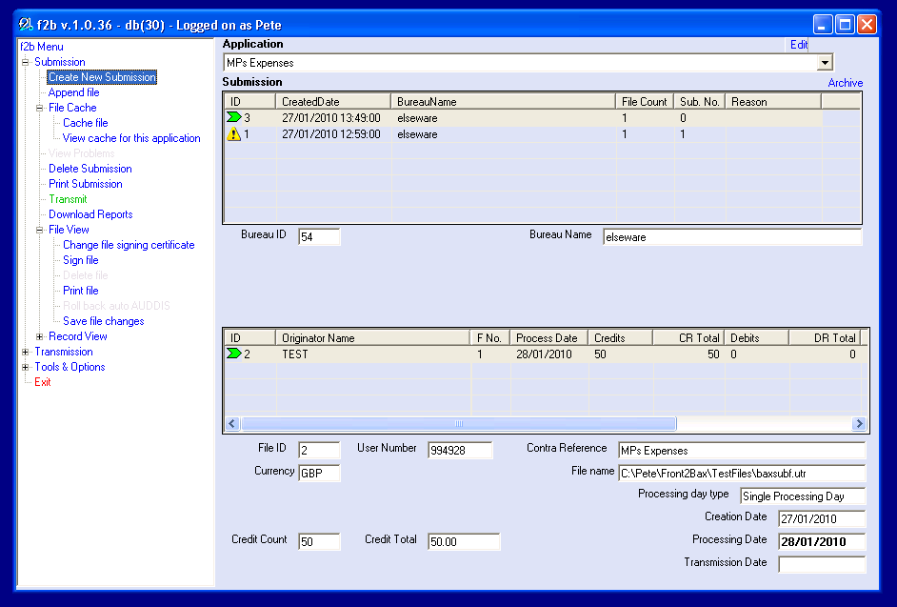

Submission Validation ONLY

Usage
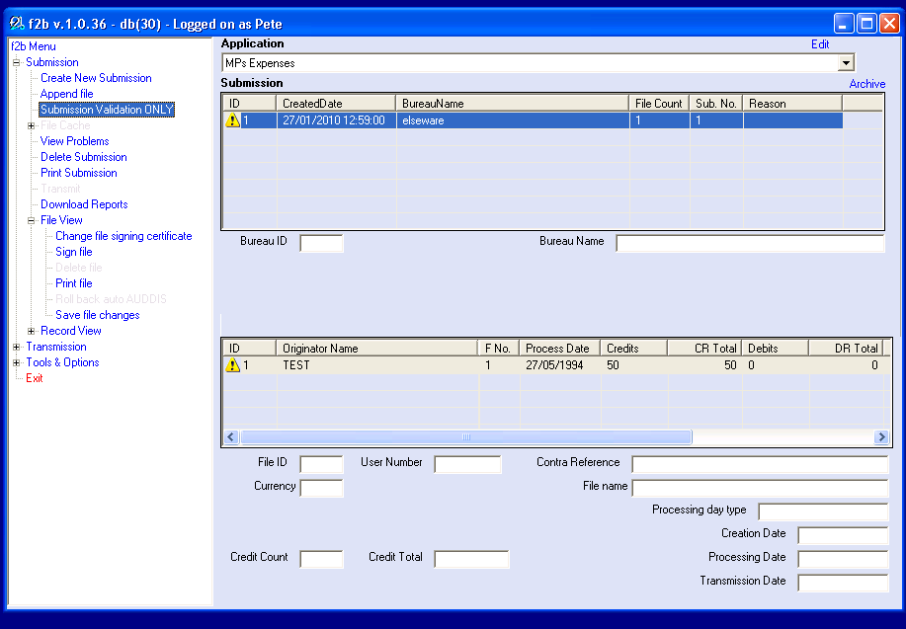

It is possible to validate a file without importing it into the system. Select Submission Validation Only from the menu and create a submission as normal. Most of the menu items will then be disabled. It will be possible to view and print the file and records, but not to transmit or alter them. In order to restore the system to normal function the validation submission must be deleted. Exiting the program in any way will cause the validation submission to be deleted.

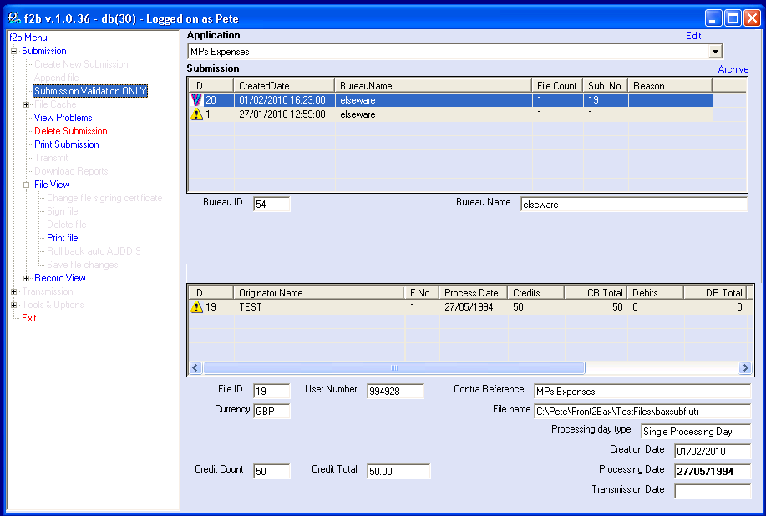
Ad Hoc Payments

Ensure that the logged in user has permission to edit records for the selected application ( see the Program Settings section )

If you are operating as a BACS bureau and do not have an individual application for each of your clients then you will need to set up an application for every client for whom you wish to make ad hoc payments. ( see the Setting Up Applications section )

To add a blank file
Select the required application and press Create Submission. On the resulting screen select the required processing date and press New Empty File. You will be returned to the records tab in the bottom half of the screen.

To add new records
If the text boxes are not currently empty you should press the Add new record button. Enter the details for the payment or debit into the empty text boxes. Press Save Changes. If you wish to save the record details for future use you should tick the ‘Store these details for future use’ tick box before saving the record.

To use stored records
Press the Use Stored Record button. In the resulting screen tick the records that you wish to use and press Use Checked Records.
If you are operating as a BACS Bureau you will see a button marked Display all stored records for all bureau applications. If you press this you will see all the stored records for all of your applications. You may select any records that you require and the program will automatically assign the records to new files as required.
AMOUNTS are stored as part of the record details and will be applied to the selected records unless overwritten. To set all the amounts in the selected records to zero press the Zero all amounts button and then select the ticked records. When returned to the records tab ensure that the amounts for all the selected records are correct. If they are incorrect then click on the required record in the records table, edit the details in the text boxes and press the Save Changes button.

To delete stored records
In the Stored Records screen tick the records that you wish to delete and press the Delete checked records button. It is not possible to edit stored records. If you wish to change a record you should delete it, add a new record from the records tab and ensure that the ‘Store these details for future use’ tick box is ticked before saving the record.

Remittance Advices

Introduction
Text in green shows items for imminent releases.

The system is able to import and store the details of a remittee. In order to create remittance advices the system does the following :

- Allows batch insertion of new remittees, overwriting duplicates.
- Matches remittees to transactions by sort code and account number.
- Produces the remittance advice document.
- Displays the document in the f2b browser ready for printing.
Future versions of the product should :
- Show listing of produced documents en masse and show email or print status. Allow selection of those to email / print and enable a ‘proceed’ button after selection.
- Allow email of the document.
- Produce address labels for printed advices.
- Allow location, editing and deletion of remittees, and occasional addition.

Remittee record
Remittee data can be included in ordinary input files, or may be imported for a separate file source. A remittee record should contain the following fields, not all of which are mandatory :

Field Name | Required | Comments
ID | Internal | Not required in input file
Sort Code | Mandatory
Account Number | Mandatory
Account Name | Optional
Title | Optional | Mandatory if first name not present
First Name | Optional
Initials | Optional
Last Name | Mandatory
Salutation | Optional
Honorific | Optional | e.g. MBE, OBE
Company | Optional
Address 1 | Mandatory | Mandatory if no email
Address 2 | Optional
Address 3 | Optional
Town | Mandatory | Mandatory if no email
County | Optional
Postcode | Mandatory | Mandatory if no email
Country | Optional
Telephone | Optional
Fax | Optional
email | Optional
ccEmail | Optional
Use email | Internal | Will default to Y if email address is present
StatusID | Internal | Not required in input file

Document format
The document is rendered in HTML from XML merged with a style sheet. This allows more style than simple text and is not operating system and version dependant as a Word document would be. The HTML, when produced, is stored on disk with the date and account name as the document title. The program has an optional switch to delete the HTML files after processing if they are not required.

Delivery
Remittance advices can be sent to the remittee in one of two ways. Each remittee will require a switch indicating whether the document should be emailed or printed.

- Email
  - The ‘from’, ‘subject’, and ‘body’ text are editable and stored in the database. In the application editing screen the user is able to select an email set from a dropdown list of descriptions and associate it with the application.
  - The document is attached to the email. This allows greater flexibility in formatting the document than if it were the body text of the email.

- Posted printout
  - The HTML is loaded into the integral system browser and automatically printed from there.
  - Address labels are sent to a Word template as this offers greater control over printing and simpler control of text formatting to label size. When printing of the remittance advices has finished the system prompts the user to change the stationary and offers a button to print the document.

DD Advices
Documents will be formatted and delivered in the same way as remittance advices.

The system will hold a figure indicating the minimum number of days between printing the DD advice and the file processing date. A warning will be raised if the operator overrides this.

When the operator creates a DD submission the DD Advices are created and printed or emailed. The system defaults the processing date of the file to the minimum number of days and the file can then be transmitted.

There is a legal requirement to issue a DD advice if the amount of the DD differs from that debited the previous month. The system can be set to only print DD advices where this is the case.

MultiLoad

The MultiLoad feature enables the loading of multiple files into a multi-file submission using a single menu click. Files can either be loaded from different folders or from a single folder. If you are loading files from different folders then you should set the file path in the Application tab of the Configure Entity screen to point to the folder specific to that application. If you are loading files for different applications from a single folder then you must include the Application ID in the file name as described below.

On the Bureau tab of the setup screen you will find the controls pictured below. In order to use the MultiLoad feature you should tick the MultiLoad box.

AutoLoad – if this box is ticked then the files will be automatically loaded when f2b is started.

Use date structured file name – If this box is ticked then the first eight characters of the name name of all of the files must represent the processing date of the file in the format YYYYMMDD. ( e.g. 20100405_CompanyAWages.txt ). If this box is not ticked then the processing date for all files is set to the next available BACS processing date. Files must have a 3 character file name extension ( e.g. .csv or .dat or .txt or whatever ).

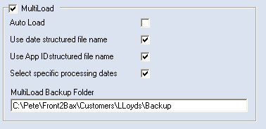

Use AppID structured file name – If this box is ticked then the first eight characters of the name name of all of the files must represent the processing date of the file in the format YYYYMMDD, the ninth character must be an underscore and the tenth to thirteenth characters must be the ID of the f2b Application to whom the file belongs, right justified and zero filled ( e.g. 20100405_0130_CompanyAWages.txt ). . Files must have a 3 character file name extension ( e.g. .csv or .dat or .txt or whatever ). The Application ID can be found in the top left hand corner of the Application setup screen as below.

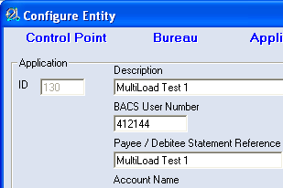

Select specific processing dates – If this option is ticked then the program will look in the folder specified for the first application and display a list of the processing dates for the files therein. Tick the dates for which you wish to process files. Only files with the selected processing dates will be processed.

If the files for different applications are to be read from a different folder for each application, rather than all files for all applications appearing in a single folder, then you should press the Display All Dates button on the date selection screen and select the appropriate dates. These dates will be applied to all the files read from all the different folders.

Processing dates for file scan be changed by entering a new processing date against the file once it has been imported into f2b and then pressing the Save File Changes menu option.

MultiLoad backup folder – If this contains text then the files will be moved to this folder after they have been loaded. If this field is empty then the files will be re-named to *.txd after they have been loaded.

Member contact numbers
Member | Customer Services Group | Contact Name | BACS Support section telephone number | Email address
Abbey National | 020 7612 5558 | Robert White  Mark Houghton | 020 7612 5558 | Robert.white@abbey.com  mark.houghton@abbey.com
Alliance & Leicester | 0151 966 3046 | Carol Rooney | 0151 966 4241 | carol.rooney@alliance-leicester.co.uk
Bank of England | 020 7601 5818 | Ian Dawes | 020 7601 4828 | ian.dawes@bankofengland.co.uk
Barclays | 0845 605 2444 | CSG Registration Team | 0845 605 2444 option 4 | cscs.bacsregist@barclays.co.uk
Co-op | 020 7480 5171 | Chris Owens | 0161 829 5446 | Chris.owens@co-operativebank.co.uk
HBOS | 0131 317 5785 | Customer Migration Team  Sharon Smith | 01422 334 844  0131 317 5785 | bacsmigration@hbosplc.com
HSBC | 0845 604 0000 option #2 | Simon Brook  Marie Walker
Lloyds TSB | 0870 902 5210 option 4 | BACSTEL-IP Helpdesk | 0870 902 5210 Option 4 | bacstelip@lloydstsb.co.uk
NAG | 0141 223 2367 | Colin Macinnes  Peter Stewart | 0141 223 2367 | colin.macinnes@eu.nabgroup.com  peter.b.stewart@eu.nabgroup.com
Nationwide | 01793 656 696
Northern Rock | 0191 522 3077
Royal Bank of Scotland* | 0131 523 2319  (pre migration)  0870 156 6680  (post migration)
NatWest* | 0870 240 5544
Coutts* | 0870 901 5601
*RBSG – (all brands) IP Migration | 0870 150 4662 | Stan Durham | 0870 153 9163 | Bacstelipmigration@rbs.co.uk

