Front2Bax
From ElseWare Ltd.

Installation Guide

Software version 1.0.21

Contact:
01438 222 225
07979 800 929
Installing the program 3
Installing the software 3
Components 3
Upgrading the software 5
To copy an existing database from one machine to another. 5
Using the software for the first time 6
Logging In 6
Setting up Applications 6
Control Point 6
Bureaux 7
Application 8
Setting up Users 10
Run the software 11
Testing 11
Testing your software 11
After installation 11
Appendices 12
SQL Server 12
Member contact numbers 13
Pre-installation check list 14
Member Variations 16
Post Installation Checklist 17
Useful contact numbers 17
Contact telephone numbers 17

Installing the program

You should ensure that the software for your smart card reader has been installed.

Installing the software
You will have received a CD containing a temporary installation program from elseWare.

Insert the CD and run f2bSetup.exe from the CD drive.

Components
Microsoft SQL Server | If you have Microsoft SQL Server installed on a network server then the database can be attached to that instance of SQL Server. F2b will run under any version of SQL Server.  If you do not have SQL Server running on a network server then you will need to install SQL Server Express onto your local PC. SQL Server Express is free.  You can download SQL Server 2008 R2 Express from here:  http://www.microsoft.com/download/en/details.aspx?id=23650  The installation package is also included on your f2b installation CD in the folder SQL 2008 R2. Please read the document on the f2b installation CD entitled Installing SQL Server 2008.
.NET | The Microsoft .NET framework. This is almost certainly already installed on your PC.  http://www.microsoft.com/net/download  The installation package is also included on your f2b installation CD in the folder DotNET Framework 4.
f2b | elseWare’s f2b program. Please run the program Setup.exe in the f2b folder on the f2b installation CD.
GEMSAFE card reader drivers | These are normally provided by your sponsoring bank. A version is included on your f2b installation CD.

You will need to notify your bank that you are using Front2Bax. BACS will not accept submissions from a package that you have not registered with your bank.

If you have any questions or require assistance when installing any of the f2b components then please call the support line on 07979 800 929.

If this is your first BACSTEL-IP package installation
If this is your first installation of BACSTEL-IP software then you should read or print out the following documents from the CD :

pn3763 Service User Guide.pdf

pn4637 Getting Started Guide.pdf

PN6200 Implementation Guide.pdf

You will need to register your smart cards as described in the Getting Started Guide.

You will need to complete the test submissions as described in the ‘Installation’ section of the Implementation Guide. When doing the test submissions ensure that the submission type button at the bottom of the transmission screen is set to ‘Structural Test’ until you are ready to do the ‘Full Test’. When you are making a live submission this button will need to be set to ‘Live’.

Upgrading the software

Go to the Start button in the bottom left hand corner of windows and select Control Panel and then Add / Remove Programs. Find f2b and press Remove. If you have an entry for the f2b Back End Components you should also remove these.

Next run the Setup.exe program in the f2b folder on the f2b installation CD.

To copy an existing database from one machine to another.

When you have installed the software on a new machine you can copy your existing data from your source machine to your target machine. The database is attached to Microsoft Sequel Sever and cannot be copied in the normal manner. Both the existing database on the source machine and the newly installed empty database on the target machine must be stopped, the data copied and then both databases must be restarted.

SQL Server 2000

To detach the database: Locate the folder C:\Program Files\f2b\db and double click on the file Detachdb.BAT

Then copy the files Indiect_Data.mdf and Indirect_Log.ldf to the new location.

To reattach the database double click on the file AttachDB.bat

SQL Server 2005 or SQL Server 2008

To detach:

- Go to the start button in the bottom left hand corner of Windows.
- Select All Programs
- Locate Microsoft SQL Server.
- From that menu item select the sub-item SQL Server Management Studio.
- If you are running Vista or Windows 7 then right click on SQL Server Management Studio and select 'Run as Administrator', otherwise just click to run.
- Press the Connect button.
- In the menu on the left there is an entry for Databases. Expand this by clicking on the + sign beside it.
- Right click on the sub-entry marked 'Indirect'.
- from the ensuing menu select 'Tasks' and 'Detach...'.
- Press OK.
- Minimise SQL Server Management Studio.

Then copy the files Indiect_Data.mdf and Indirect_Log.ldf to the new location.
To re-attach:
- If SQL Server Management Studio is not running then please follow steps 1 to 6 above.
- In the menu on the left of SQL Server Management Studio, right click on databases.
- Select 'Attach...'.
- Press the button marked 'Add...'.
- Browse to the folder C:\Program Files\f2b\db ( C:\f2b\db if you have Vista ot Windows 7 ).
- Click on inDirect_Data.mdf and press 'OK'.
- Press OK.
- The database 'Indirect' should now be listed in the window on the left under Databases.
- Close SQL Server Management Studio.

Using the software for the first time

Logging In

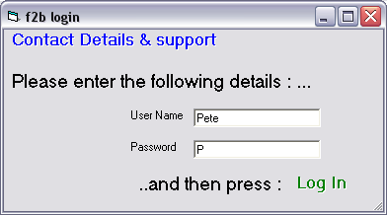

When you first run the software you will be prompted to log in. Leave the user name and password blank and you will be logged in as the user Pete with the password p. You should change this user name and password at the earliest opportunity.

Setting up Applications

Control Point

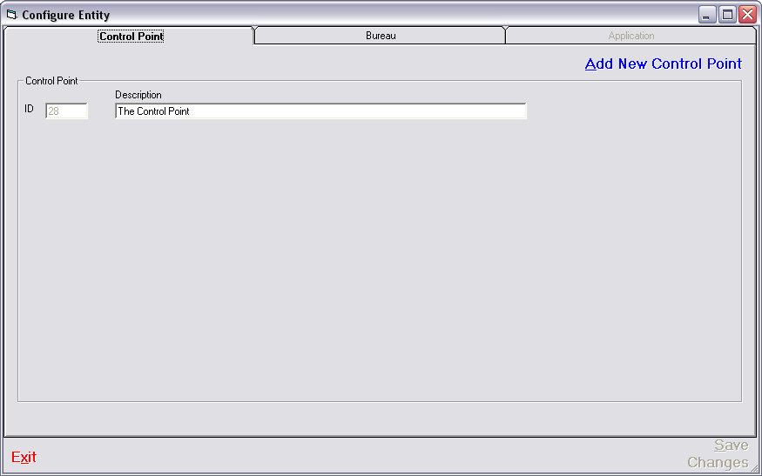
The Control Point is used for grouping Bureaux and Applications.
If you change the text you should press Save Changes and then Exit.
Description
Enter a description for the Control Point, e.g. your company name

Bureaux

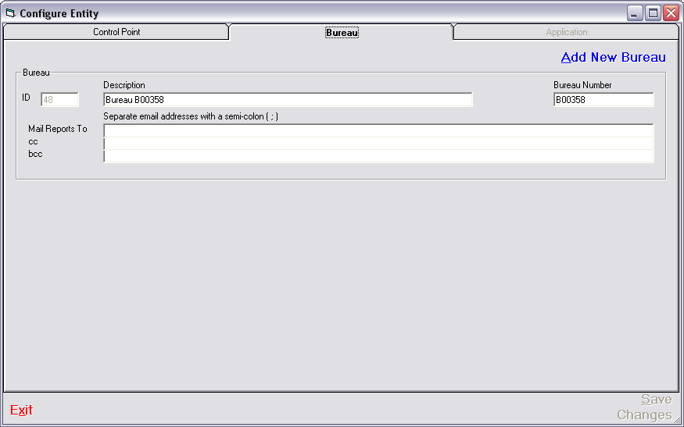

If you are not operating as a BACS bureau you should not enter a bureau number. The bureau entry can be used to group Applications into logical groupings.

If you are operating as a BACS Bureau you should group your clients under one or more Bureau entries. Bureau entries can have the same BACS bureau number or different bureau numbers.

If you change the text you should press Save Changes and then Exit.

Description
Enter the name of the bureau, e.g. your company name. If you will be entering more than on bureau then the names should be different.

Bureau Number
If you are operating as a BACS bureau you should enter your bureau number. If you are not a BACS bureau then you should leave this field blank.

The following are not active in the current version of the program :

Mail Reports To
Copies of reports and notifications of significant events for all applications grouped under this bureau number will be sent to the people or mail groups specified in this list.

CC
Copies of reports and notifications of significant events for all applications grouped under this bureau number will be sent to the people or mail groups specified in this list as entries on the cc line

BCC
Copies of reports and notifications of significant events for all applications grouped under this bureau number will be sent to the people or mail groups specified in this list as entries on the bcc line ( no other recipients in the list will see that these users or groups have been sent a copy ).

Application
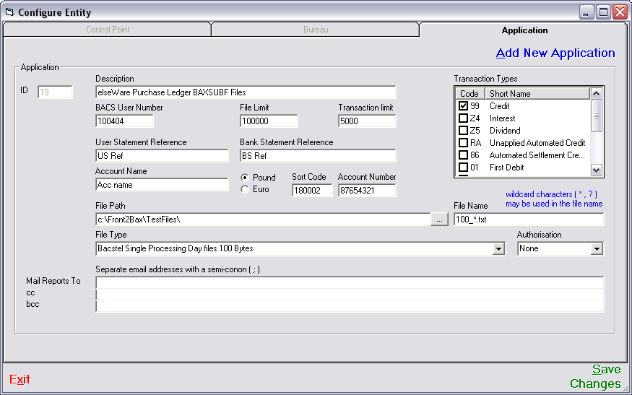

An application is a set of details that are merged with a set of credits or debits to make a BACS submission. They identify the bank account from which the credits will be taken or into which the debits will be paid.

If you change any of the text you should press Save Changes and then Exit.

Description
The description of the Application ( e.g. Company A Payroll, Company B Pension Contributions, Company C VAT, etc.. ). This description is displayed in the program to enable the user to select the correct set of details. Any combination of text and numbers can be entered.

Transaction Types
The type of transactions to be used with this BACS User Number. Most BACS User numbers are automatically set up to make payments. If you wish to collect Direct Debits you should contact your sponsoring bank.

If you are making payments you should tick 99 - Credit.
If you are collecting Direct debits you should tick : 01 - First Debit, 17 - Debit, 18 – Represented Debit and 19 – Last Debit.
If you will be issuing Direct Debit Instructions you should tick : 0N – New DDI, 0C – Cancel DDI and 0S – Set up DDI.

BACS User Number
The BACS User Number for this application. If you are operating as a BACS Bureau you should enter the BACS User Number of your client.

File Limit
The maximum amount of money allowed to be credited to or debited from this account in one file ( set of transactions ). A warning will be given if this amount is exceeded.

Transaction Limit
The maximum amount of money allowed to be credited to or debited from this account in a single transaction within a file ( set of transactions ). A warning will be given if this amount is exceeded.

User Statement Reference
The text to be printed on the bank statement of the account associated with this user number. If you are operating as a BACS Bureau his text will appear on your client’s bank statement.

Bank Statement Reference
The text to be printed on the bank statement of the person being paid or debited as a result of transactions created using this application.

Account Name
The name of the bank account from which credits are to be made or into which debits are to be received.

Currency ( Pound / Euro )
The currency in which the transactions are to be made. Transactions in Euros are not currently possible ( June 2005 ) but will be implemented shortly. Until such time any sets of transactions that specify Euros as a currency will be processed as pounds with no rate conversion in operation.

Sort Code
The sort code of the bank account to be associated with this BACS User Number. Several bank accounts can be associated with a single BACS User Number.

Account Number
The account number of the bank account to be associated with this BACS User Number. Several bank accounts can be associated with a single BACS User Number.

File Path (& browse button )
The path along which the files of payments or debits can be found. If your file is situated on a shared drive the path might be : ‘F:\Shared\Payroll\’. You can use the browse button ( with the three small dots on it ) to select a path.

File Name
The name of the file or type of file to be presented for submission to BACS. Wild cards can be used. Your file name might be : ‘Payroll Week 10.txt’ or ‘Pay*.txt’ or ‘Payroll Week ??.txt’

File Type
The type of file that contains your set of credits or debits. If the type of file that you will be using does not appear in the drop down list, or you are unsure of the type of your file you should contact your software supplier.

Authorisation
This is not currently in use.

The following are not active in the current version of the program :

Mail Reports To
Copies of reports and notifications of significant events for the application will be sent to the people or mail groups specified in this list.

CC
Copies of reports and notifications of significant events for the application will be sent to the people or mail groups specified in this list as entries on the cc line

BCC
Copies of reports and notifications of significant events for the application will be sent to the people or mail groups specified in this list as entries on the bcc line ( no other recipients in the list will see that these users or groups have been sent a copy ).

Setting up Users
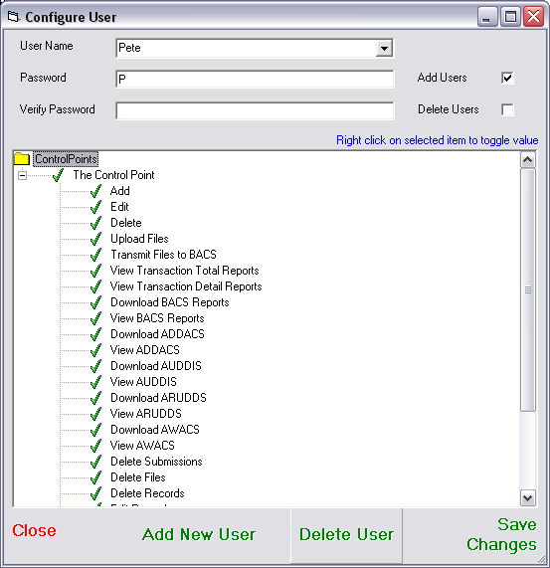

User name
The name of the user.

Password
The user’s password
Verify Password
Repeat the user’s password

User Permissions
Set the permissions for the user.

Run the software
For instructions on how to run the software see the f2b User’s Guide.

Testing
Install your new BACSTEL-IP software
Install your smartcard readers and the signing software
The PSCs should register their smartcards. If you have ASM you should also ensure that you have your contact ID and password

Testing your software
Before using your BACSTEL-IP software for live submissions, you must perform a few tests. If you will be using your BACSTEL-IP software for more than one service user number, then you need to complete the tests for each service user.
The tests are recorded in a “service qualification plan” that is linked to your software.
Your software supplier can help you complete these tests as part of the installation; the tests will also form part of your training.
Here are the tests:

1. Log on to BACSTEL-IP using your software
After the PSCs have registered their smartcards, your can connect and then log on to BACSTEL-IP using your software. When you have logged on successfully, the test is complete.
2. Access generic test reports
BACSTEL-IP has a “generic test report”; this is a sample report, used to make sure you can access reports. Once you have successfully accessed the report, then the test is complete.
3. Make a test submission that undergoes online validation
When you send a submission, BACSTEL-IP performs certain checks on it while you are still online. When these checks are done, BACSTEL-IP sends you a submission summary report confirming that the submission has been received and whether it was accepted for further processing. When a submission is accepted, the test is complete.
4. Make a test submission that undergoes full live simulation testing
Your bank may not require you to perform this test; they will let you know if you need to. For this test, you send a test submission that goes through full test processing. This produces a test input report. Your bank will check this report to see if there were any issues during processing. After sending the submission, it may take one or two days before your bank can confirm if the test is OK.

Once testing is complete, your or your software supplier should contact your bank to notify them. When your bank is satisfied things are working, they update your service qualification plan so your BACSTEL-IP software is ready for live submissions. (If you performed the live simulation test, this may take one or two days.) Your PSCs will receive an email when this is done.

After installation
Once the installation is completed and your software is live, you are ready to start using BACSTEL-IP. Issues with your software should still be directed to your software supplier. Other issues should be directed to your bank (although if your bank has a dedicated implementation team, you may need to speak to a different section) or the BACS service desk.
If you do not already have them, make sure you get your..

BACSTEL-IP – Service user guide
Getting started guide – BACSTEL-IP for direct submitters

You can download these guides from http://www.bacstel-ip.com/

Appendices

SQL Server

If you intend to attach the database to an instance of SQL Server then you will need to do the following :

- Copy inDirect_Data.mdf and inDirect_Log.ldf from the EmptyDb directory on the installation CD to your server.
- Using SQL Server Manager attach the database to an instance of SQL Server.
- Set up users for the database and assign them permissions to execute all the stored procedures that begin with sp_
- On the client machines open ‘C:\Program Files\f2b\f2b.ini’ and edit the line that says ‘Server=(local)’ so that it says ‘Server=<your server name>’

Member contact numbers
Member | Customer Services Group | Contact Name | BACS Support section telephone number | Email address
Abbey National | 020 7612 5558 | Robert White  Mark Houghton | 020 7612 5558 | Robert.white@abbey.com  mark.houghton@abbey.com
Alliance & Leicester | 0151 966 3046 | Carol Rooney | 0151 966 4241 | carol.rooney@alliance-leicester.co.uk
Bank of England | 020 7601 5818 | Ian Dawes | 020 7601 4828 | ian.dawes@bankofengland.co.uk
Barclays | 0845 605 2444 | CSG Registration Team | 0845 605 2444 option 4 | cscs.bacsregist@barclays.co.uk
Co-op | 020 7480 5171 | Chris Owens | 0161 829 5446 | Chris.owens@co-operativebank.co.uk
HBOS | 0131 317 5785 | Customer Migration Team  Sharon Smith | 01422 334 844  0131 317 5785 | bacsmigration@hbosplc.com
HSBC | 0845 604 0000 option #2 | Simon Brook  Marie Walker
Lloyds TSB | 0870 902 5210 option 4 | BACSTEL-IP Helpdesk | 0870 902 5210 Option 4 | bacstelip@lloydstsb.co.uk
NAG | 0141 223 2367 | Colin Macinnes  Peter Stewart | 0141 223 2367 | colin.macinnes@eu.nabgroup.com  peter.b.stewart@eu.nabgroup.com
Nationwide | 01793 656 696
Northern Rock | 0191 522 3077
Royal Bank of Scotland* | 0131 523 2319  (pre migration)  0870 156 6680  (post migration)
NatWest* | 0870 240 5544
Coutts* | 0870 901 5601
*RBSG – (all brands) IP Migration | 0870 150 4662 | Stan Durham | 0870 153 9163 | Bacstelipmigration@rbs.co.uk

Pre-installation check list
 | Item | Member variations
 | Order the BACSTEL-IP software from your software supplier | NAG may require customer to complete their Registration Form in conjunction with the solution supplier.
 | Are there any additional requirements resulting from the preinstallation briefing?  NB Have you ensured that the software solution will work on your PC and with your operating system ? | LTSB customers will not require a briefing, however customers using NT4 may need a patch from LTSB CSG (see contact telephone numbers) for the cards to work.
 | Has the installation date been confirmed between the software supplier and the customer and a contact name been agreed?
 | Has the Member been notified of the installation date and confirmed prior delivery of card readers/cards and signing solution software? | LTSB customers – not applicable.  HSBC will send smart card and signing solution software direct to customer  NAG will issue signing solution software and one set of cards but may require the solution supplier to carry a master set to the installation.  LTSB will provide the solution supplier with spare signing solution software  HBOS request a minimum of 4 weeks lead-time prior to the installation date, to ensure all documentation is completed, keyed and the smart cards ordered in time.  BofE will send out smart cards 2-3 wks prior to installation date.
 | Has the customer confirmed both PSCs availability on site for installation date?
 | Ensure that the computer which is to be used for installation will be available without interruption during the installation process?
 | Has the solution supplier been provided with a sample file and does the customer have a sample of ‘live’ data available for use during the test submission?
 | Has customer received signing solution software, card reader and smart card? | HBOS and RBSG customers will receive a pack with smart card, signing solution software, card reader.  Barclays eSigner 2.1 signing solution software should be supplied by Solution Supplier but under Barclays/Gemplus licence ie paid for by Barclays.
 | Has the customer got a spare card reader in case there is a problem with the supplied ones?
 | Has the customer received the DN email and saved it to a secure folder?
 | Have customers using the Dial Up Extranet received the extranet Id and password and saved them to a secure folder?
 | Has customer received PIN? | HBOS customers – PIN will be sent to a different address possible personal one, check that they will have this on the day. RBSG PIN to be dispatched by post to named contact.  NAG will post the PIN to the individual contacts’ personal address upon receipt of letter from customers nominated contact acknowledging receipt of smart cards.  LTSB customers will need to have returned their card and PIN receipt
 | If relevant, has the customer got the BACS ‘Getting Started Guide’ or the details of where this is on the BACS web site ?  www.bacs.co.uk/bacstel-ip/downloads/getting_started_guide.pdf | HBOS will issue the url to the customer prior to registration
 | Has the customer got the freepost envelope for returning their BacSafe device at a later date? | RBSG will allow customer parallel running based on the submission frequency, prior to requesting return of device.  NAG may set up a process to diarise a request to the customer to cancel the device, they will also develop a process to deal with the return of the device.  Barclays may monitor the submission history before canceling the BacSafe device. Barclays customers should be advised to return the BacSafe device to BACS after completing their first submission.
 | Has the customer requested that they go ‘live’ by phoning the Member after testing? | HBOS prefer the software supplier to contact the CSG to advise that the customer is ready to go ‘live’, in addition, or, if this is not possible HBOS may monitor the Activity Log to change customers to ‘live’. Once ‘live’ status is given by the Member, a confirmation email goes to Service User’s PSCs.  In some cases a telephone call to the Member may have be arranged in advance to confirm ‘live’ status.  RBSG require the Solution Supplier to update the daily MI report to reflect successful install by changing the status code. File to be dispatched to RBSG operation by 11:00hrs next working day for the ‘live’ status to be keyed by midday. On exception basis the Solution Supplier can ring the IP migration telephone number, then secret option 6 and advise the customer install success, migration team will then check the SQP and switch customer to ‘live’. Once ‘live’, the customer will be issued a ‘Congratulations’ letter and re-advised of the relevant CSG number.  LTSB send all Smart Cards and Pins to a known authorised signatory who is responsible for distributing them to contacts inside the organisation. Prior to commencing the SQP and before setting a user to ‘live’ LTSB require the smart card and PIN receipt to have been returned by the customer and LTSB need to ensure that the correct DN has been captured.  NAG prefer the software supplier to contact their CSG to advise that the customer is ready to go ‘live’, in addition via fax or telephone.  HSBC & NAG will monitor the Activity Log to change customers to ‘live’. Once ‘live’ status is given by the Member a confirmation email goes to NAG and HSBC Service User’s PSCs. NAG may monitor the SQP to change customers to ‘live’ once you have called their CSG.  Once ‘live’ status is given by the Member a confirmation email goes to Service User’s PSCs. In some cases a telephone call or fax to the Member may have be arranged in advance to confirm ‘live’ status.  Both Bank of England and Barclays prefer you to contact their CSG to advise that the customer is ready to go ‘live’. Bank of England may monitor the Activity Log to change customers to ‘live’.  Barclays may monitor the SQP to change customers to ‘live’ once you have called the CSG. Once ‘live’ status is given by the Member a confirmation email goes to Service User’s PSCs.  Barclays CSG can be contacted on the number provided above.

Member Variations

Abbey National
Alliance & Leicester
CO-OP
HBOS
RBSG

1. The customer will have already received the card reader, smart card and signing solution
software. Future RBSG card readers will be combined USB/serial port, called GemPC Twin. The pack that RBSG distribute will contain a card reader and cables for both USB and serial port connections. When installing you will need to select the GemPC Twin driver instead of the USB or Serial Port driver.
2. The customer may have installed these and tested them out. RBSG require the Solution
Supplier to install the card reader and driver unless the customer is using existing card reader
and signing solution software.
3. The customer will have received various emails from the Member and from BACS and stored them in a secure folder. (You will have checked this with them prior to visit).
4. The customer’s PKI DN written into the smart card may have already been registered on
BACSTEL-IP if they have installed the signing solution software.
If the signing solution software has not been installed you should install it at this point although
some software packages require the signing solution software to be installed first. (NB Gemplus software requires a ‘Transport PIN’ to be entered and a new password to be created at that point for added security).

HSBC
LTSB
NAG

1. The customer will have already received the smart card & signing solution software.
2. The customer will have received various emails from the Member and from BACS and stored them in a secure folder. (You will have checked this with them prior to visit).
3. The customer’s PKI DN written into the smart card will have been registered on BACSTEL-IP. HSBC, LTSB and NAG will require you to provide and install the card reader. (NB Gemplus requires a ‘Transport PIN’ to be entered and a new password to be created at that point for added security)

Bank of England
Barclays

Only the smart card will have been received by the customer.
1. The customer will have received various emails from the Member and from BACS and stored them in a secure folder. (You will have checked this with them prior to visit).
2. The customer’s PKI DN written into the smart card will have been registered on BACSTEL-IP. You will need to provide and install the smart card reader and signing solution software.
(NB Gemplus requires a ‘Transport PIN’ to be entered and a new password to be created at that point for added security)

Post Installation Checklist
Has the customer been given training?
Has the customer been shown the payments service web site? Details are available in the BACSTEL-IP Service User Guide document
Has the customer been shown how to make a back-up copy of the software for contingency purposes?
Has the customer been given details of the ‘Getting Started Guide’ ?
Has the customer got the software supplier’s contact details ?
Has the customer got the FreePost envelope for BACSAFE returns?
Is customer aware that if they are using BT Cadan or Dialplus they may need to cancel this by writing to BT (the provider)
See ‘Useful Contact Information’

Useful contact numbers

Contact telephone numbers

BACSTEL-IP Migration Project Desk at BACS: 020 8951 7870
(In the event of BACS technical support being needed during installation)

To cancel a BT Dialplus or CADAN connection:
Customer must write or fax on letter headed paper, including their dialplus account number and
Calling Line Identification number (CLI) to:
BT Dialplus Order Management
pp FYR1
Fyrish House
Dail Nan Rocas
Teaninich Industrial Estate
Alness
Ross-Shire
IV17 0PH
Or
Fax: 01847 894 330
(The12 month minimum contract term will apply
The customer will receive acknowledgement that the cease has taken place in their final bill from BT)
Further details of the above can be found on
www.bacs.co.uk/BACSTEL-IP/direct/dialplus_contracts.php

